Go to: Fliptheswitchcampaign.org
Scroll Down to Get Trained, Click on Start Training
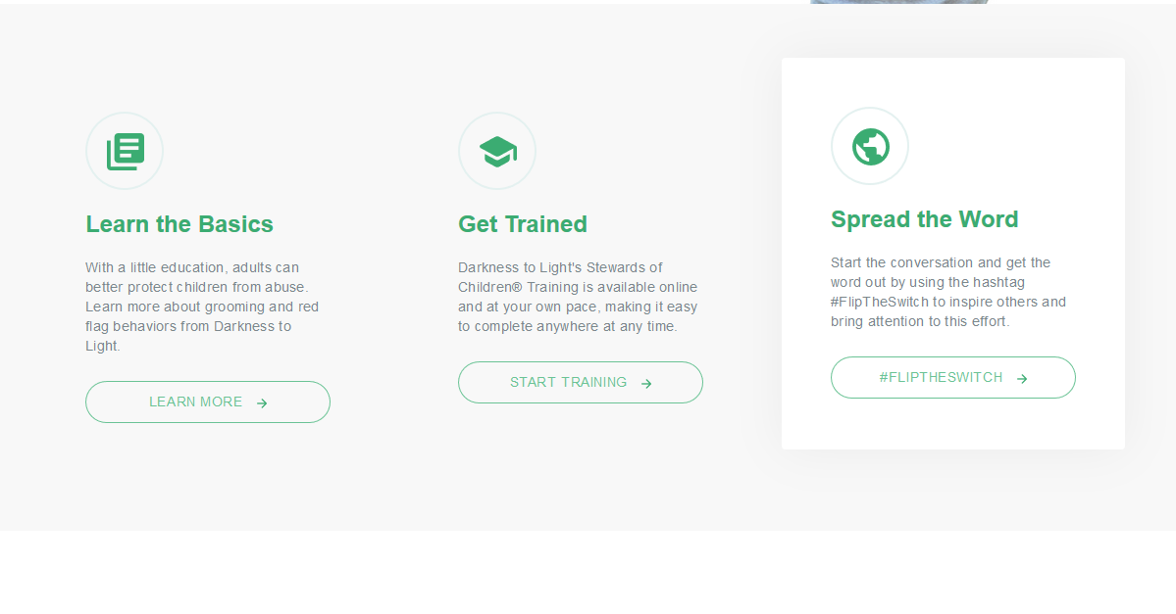

Click on GET STARTED
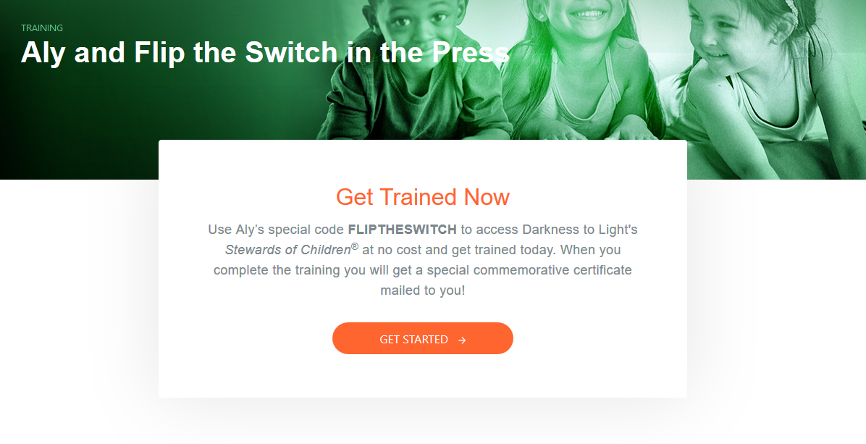

Click on START TRAINING
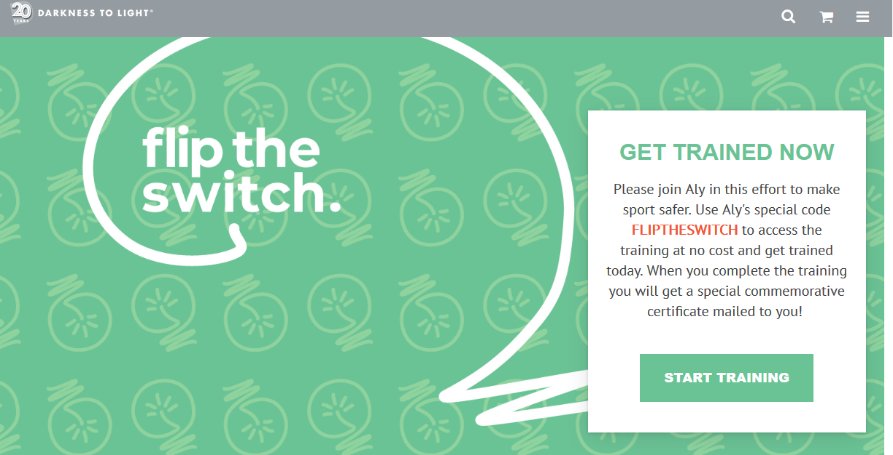

Click on Request
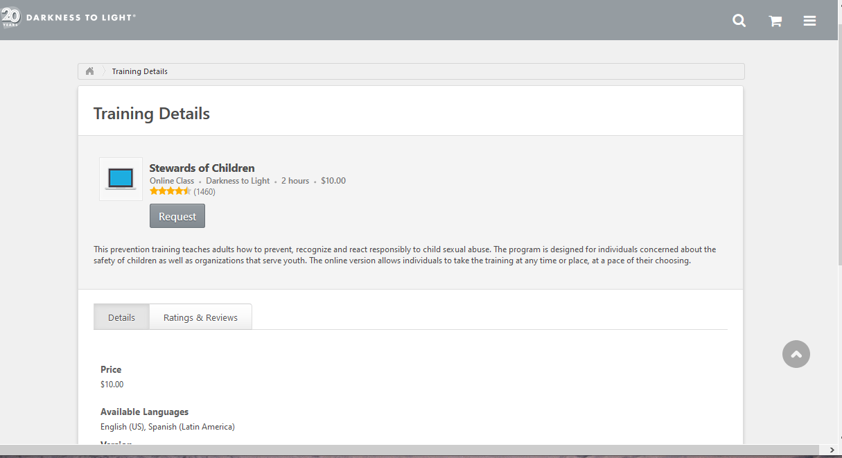

Register
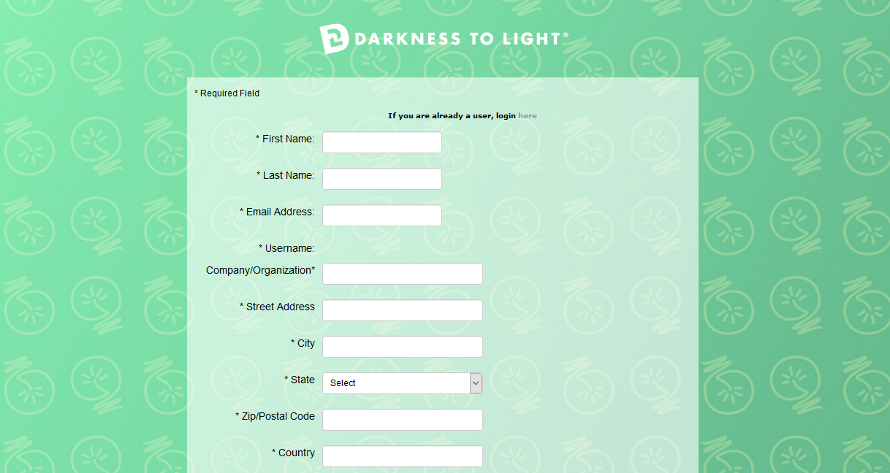

Click on Stewards of Children
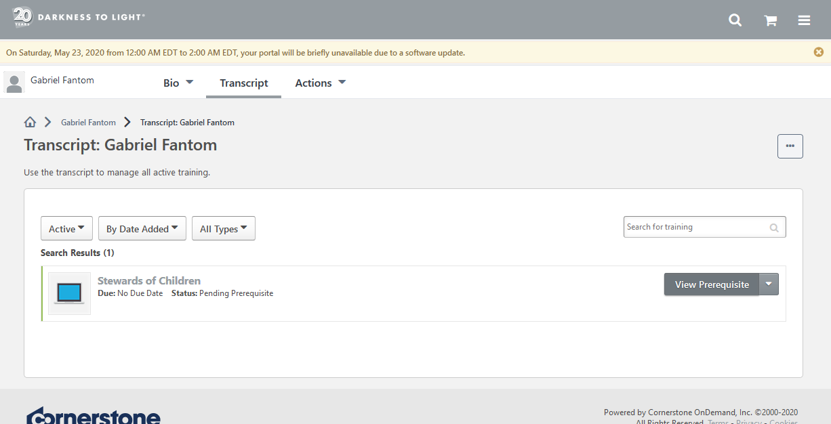

Scroll Down, Click on Stewards of Children Survey
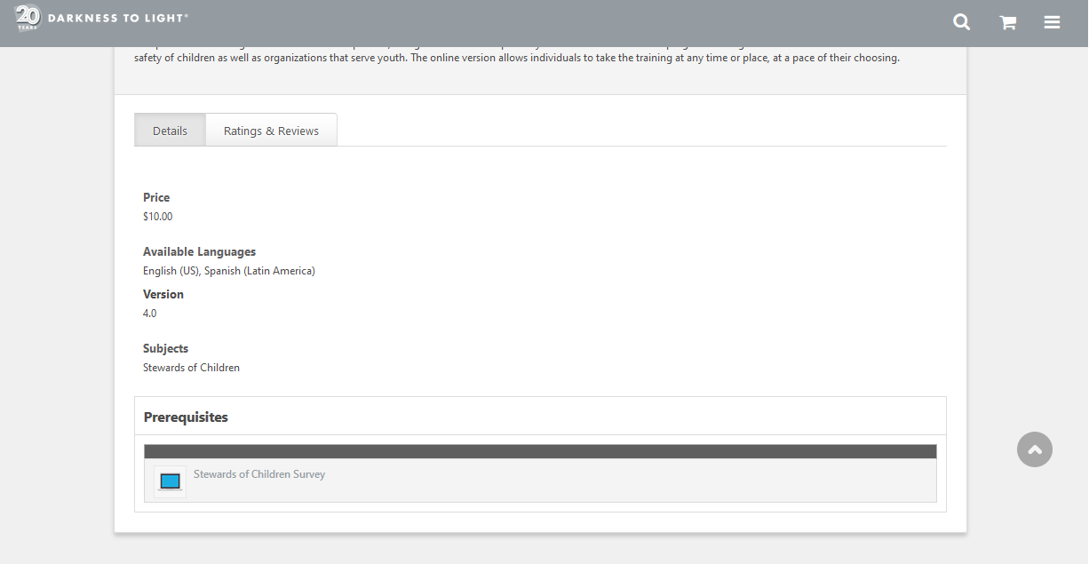

Complete the prerequisite survey.

Click on the Darkness to Light Icon when survey is complete.
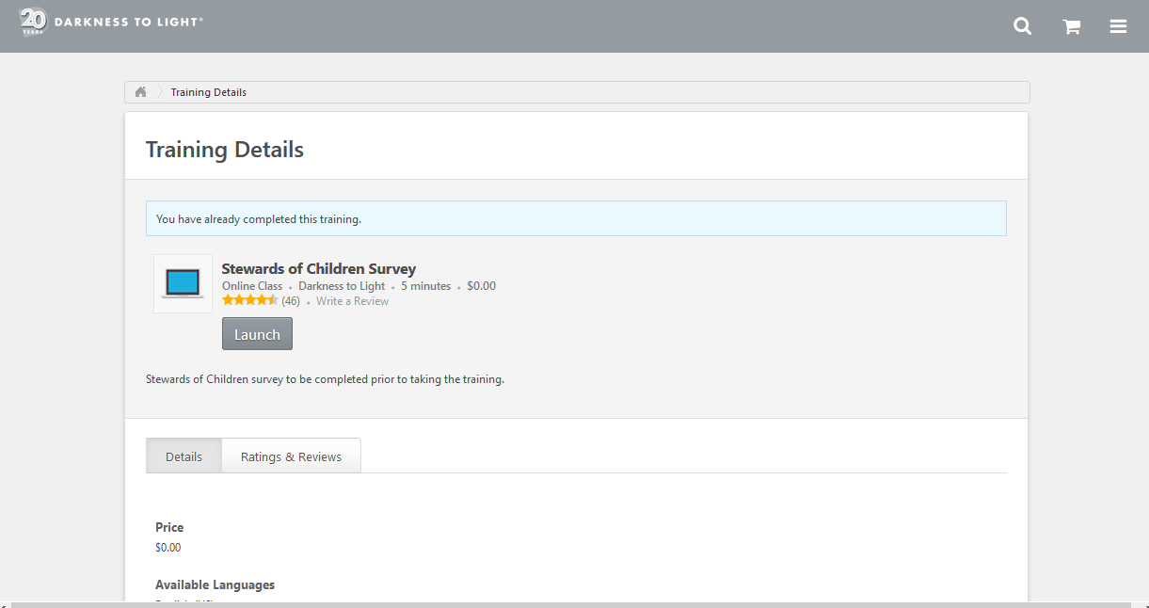

Scroll Down to View In Progress Training and Click on it
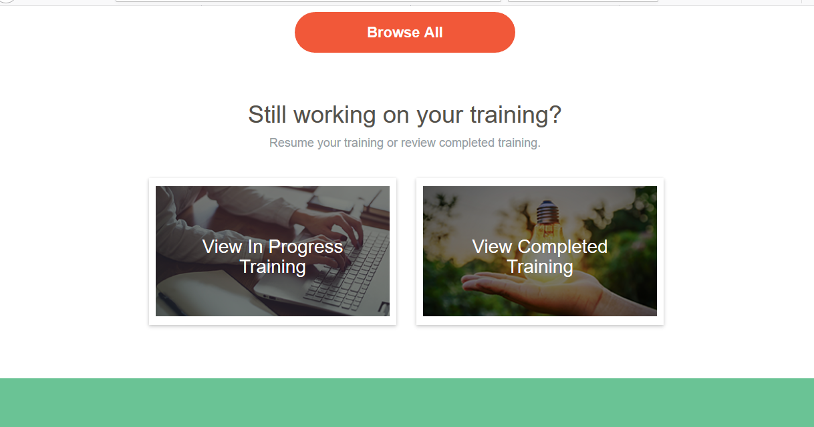

Click on Register
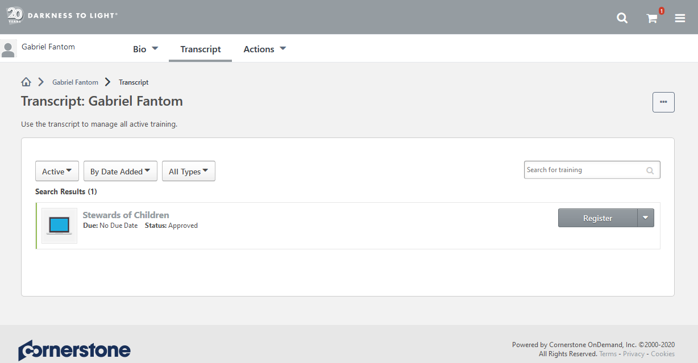

Under Purchase Summary, fill in the Coupon Code FLIPTHESWITCH and Click APPLY
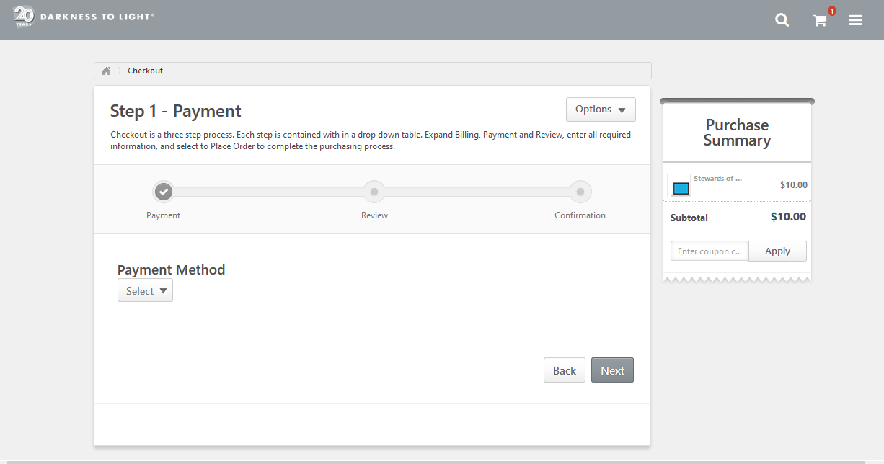

Click Place Order
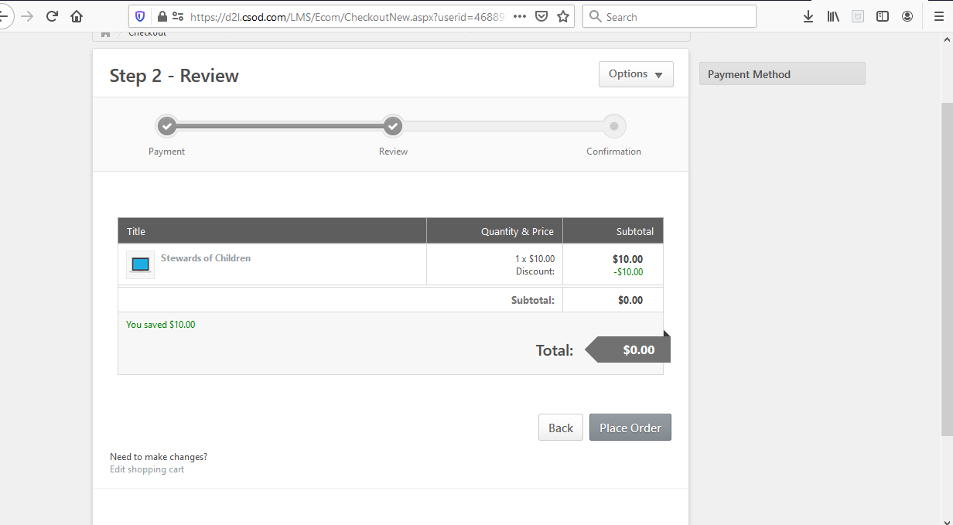

Follow the pop up instructions to start the training!

